* As stated in the slides 80% of consumption is a function of temperature
* Consumption, which is by convention denoted h, follows a sigmoid function of temperature of the form:

$h(T) =D + A / (1+{(B/(T - 40))}^{C})$

where D is the minimum consumption and A, B and C shape coefficients, note that A is always close to the h(T) when t $→$- $∞$

* The shape of this curve is as follows

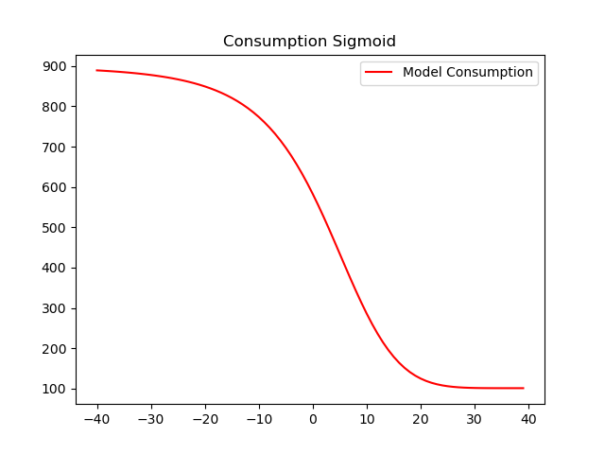

* For this curve D and A are always positive, B is always negative and C is never an integer.
* So, for temperatures equal or higher than 40 calculating this function will yield an error.
  + This is because for T = 40 we will divide B by 0
  + For T > 40 (T-40) becomes positive and so B/(T-40) is negative and since C is never an integer and basic algebra tells us that:
    - If x $ϵ { ℜ}^{-}$ and y $ϵ Q$ then $×^{y}$ is not in $ℜ$
* The first step of this project is to use the excel DE.csv and to find the parameters A, B, C, and D, by regressing the consumption on the actual temperature
* This excel contains 4 columns (Date: the Date, LDZ: Consumption in GWh, Actual: Actual temperature, Normal: Normal Temperature)